3.GIT LAB

GIT STATEMENT:-

GIT DESCRIPTION:-

PROCEDURE:-

Git is a free and open-source version control system, originally created by Linus Torvalds in 2005. Unlike older centralized version control systems such as SVN and CVS, Git is distributed: every developer has the full history of their code repository locally. This makes the initial clone of the repository slower, but subsequent operations such as commit, blame, diff, merge, and log dramatically faster.

Git also has excellent support for branching, merging, and rewriting repository history, which has led to many innovative and powerful workflows and tools. Pull requests are one such popular tool that allows teams to collaborate on Git branches and efficiently review each other's code. Git is the most widely used version control system in the world today and is considered the modern standard for software development.

GIT COMMANDS:-

* git congfig :

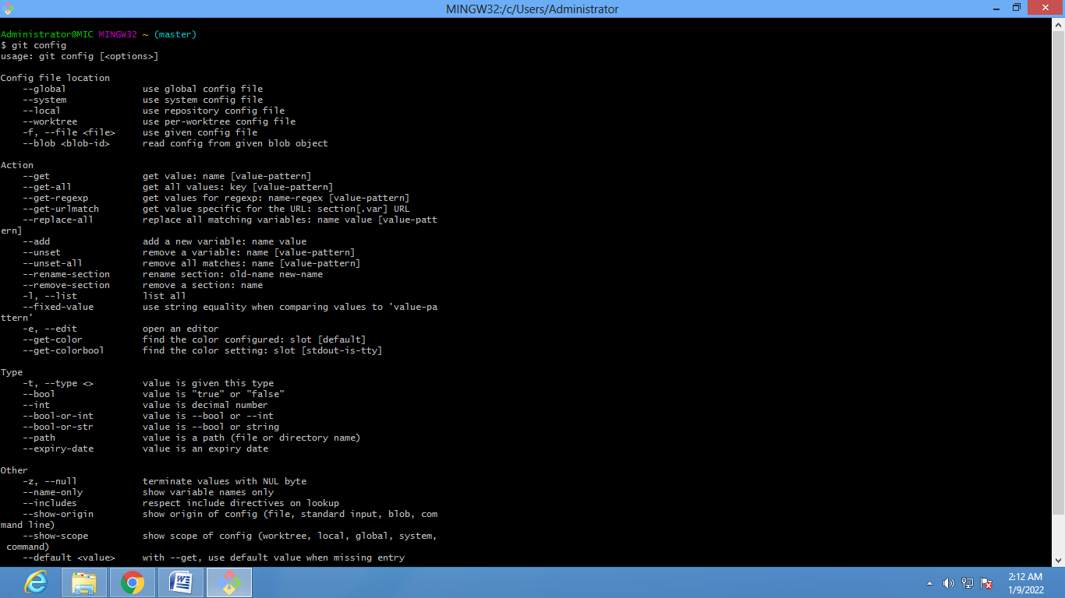

* git config - -global user.<your email> :-

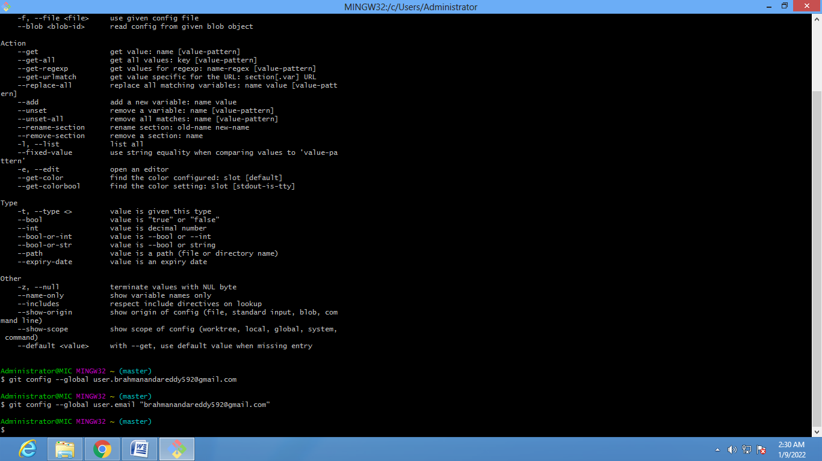

* git config - -global user.<Name> : -

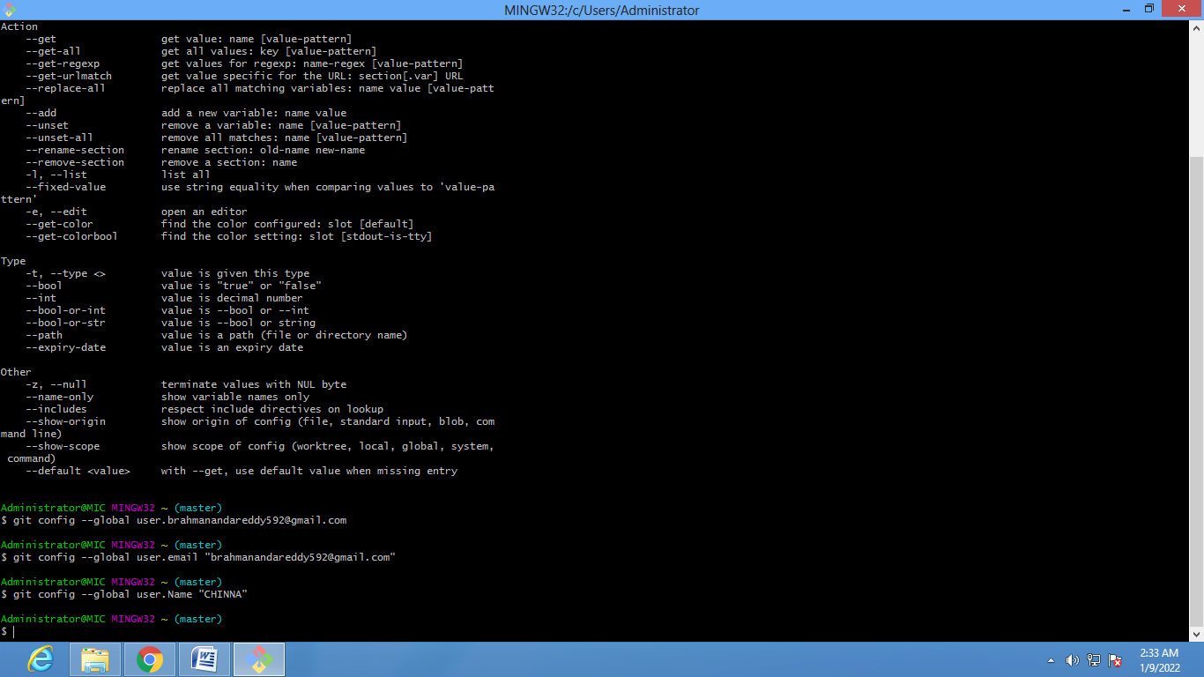

* git init :-

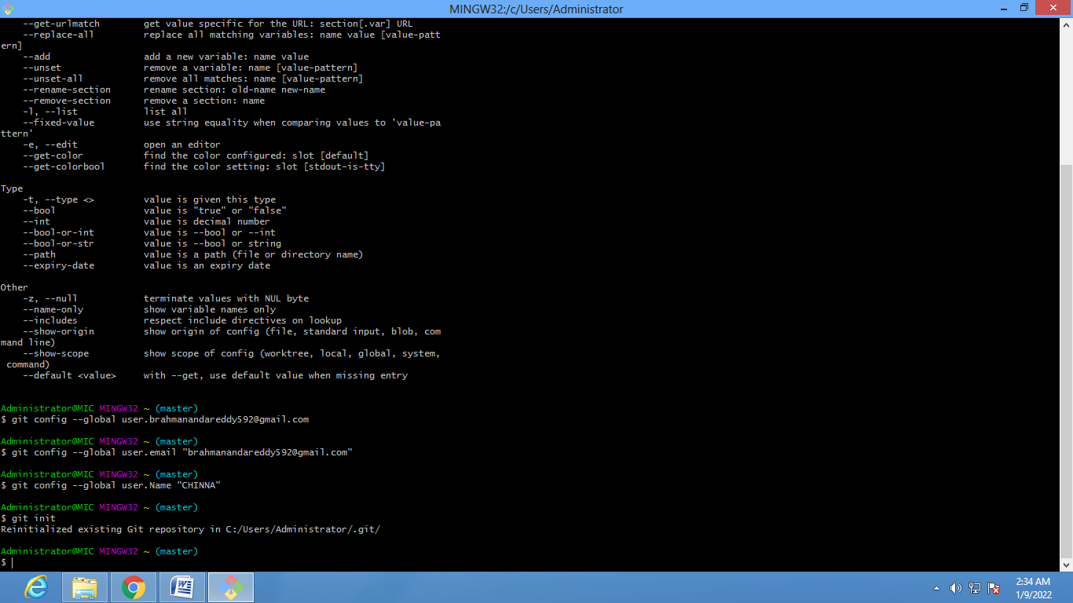

* git cd D:-

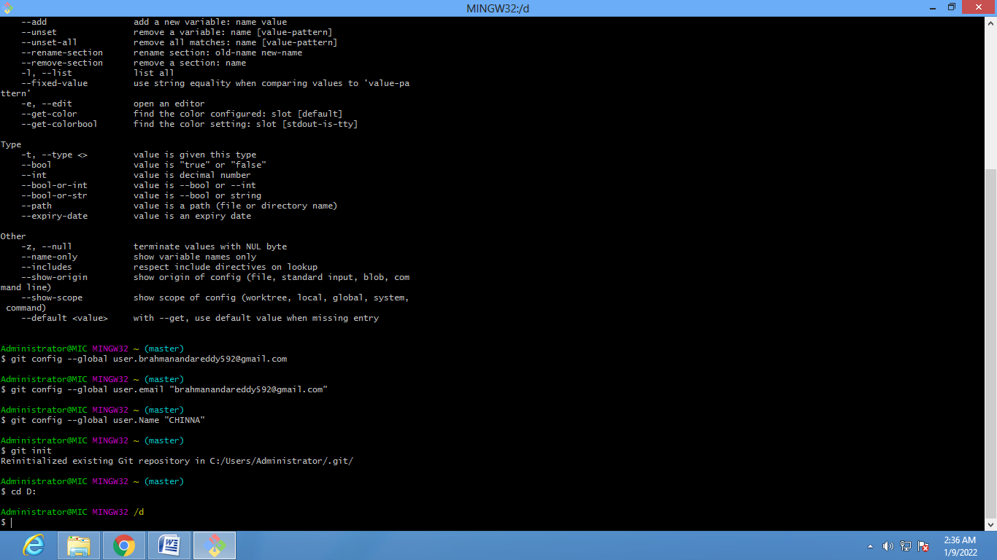

* mkdir <create your file name>:-

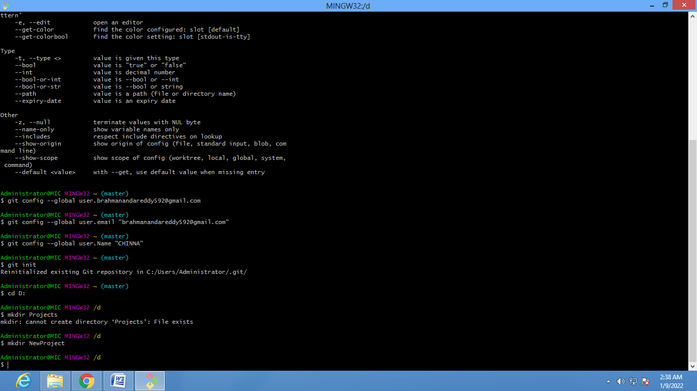

* cd <your file name>/ :-

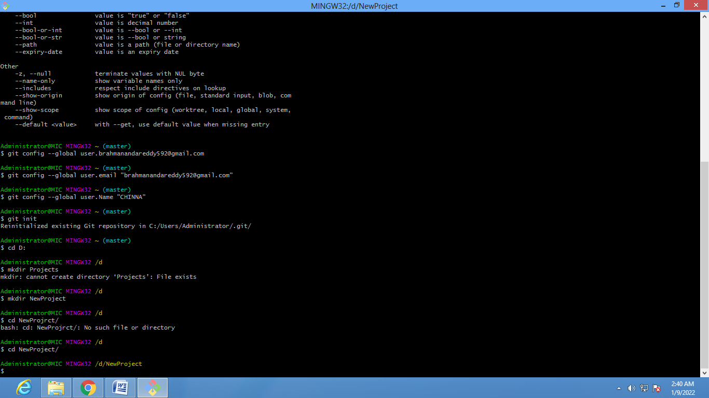

**CONFIGURE GIT BASH TO GITHUB:-**

* git clone <github url> :-

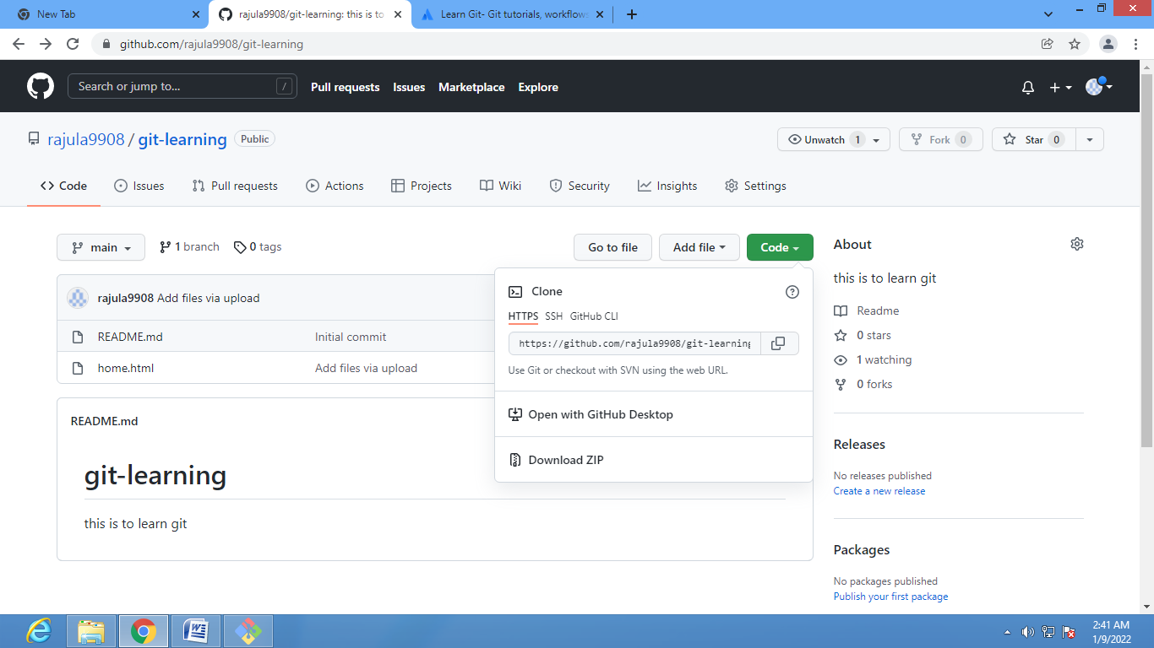

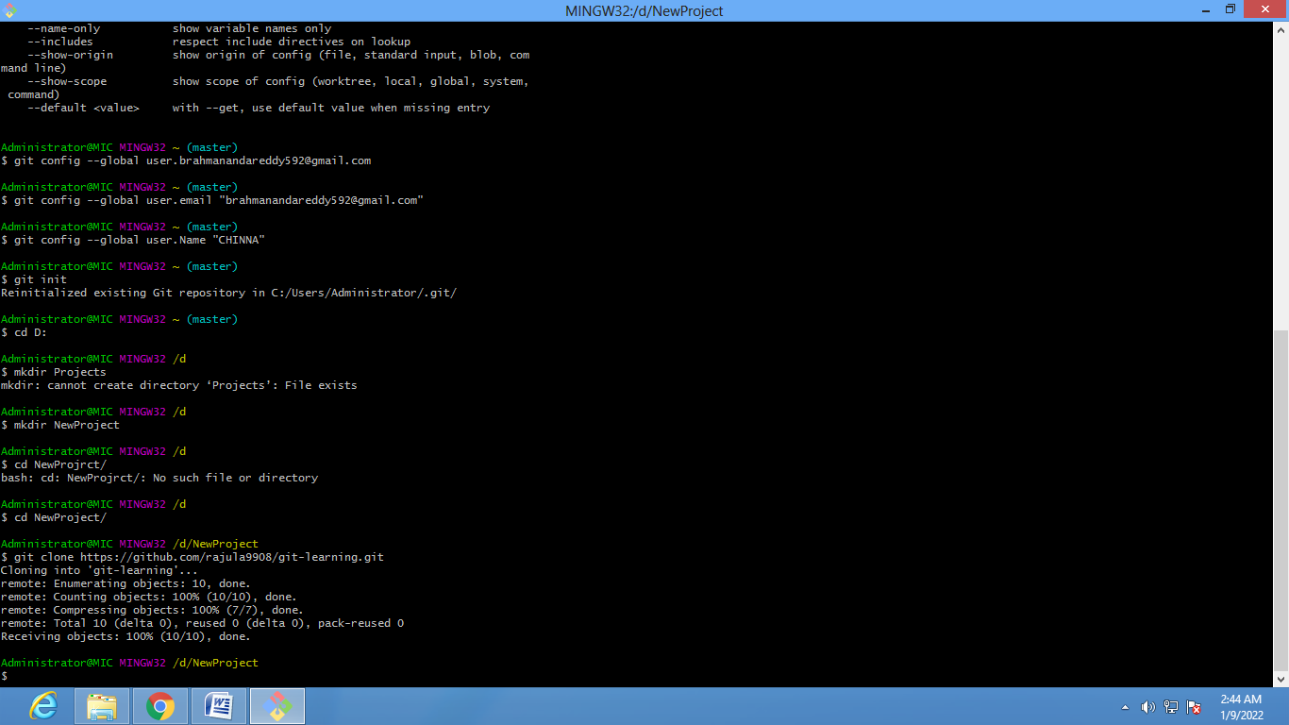

* ls :-

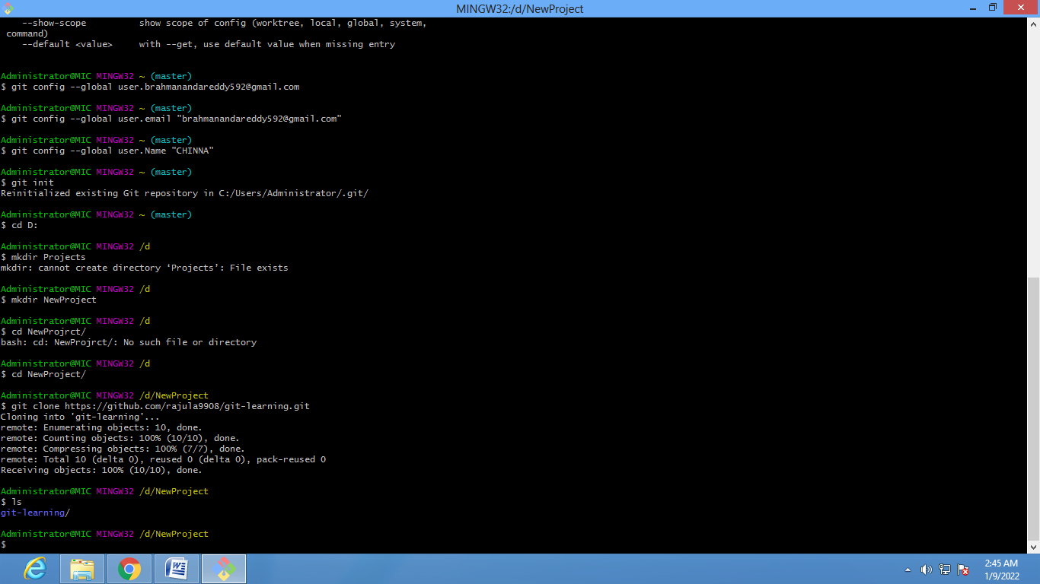

* cd <git-hub repositray name> /:

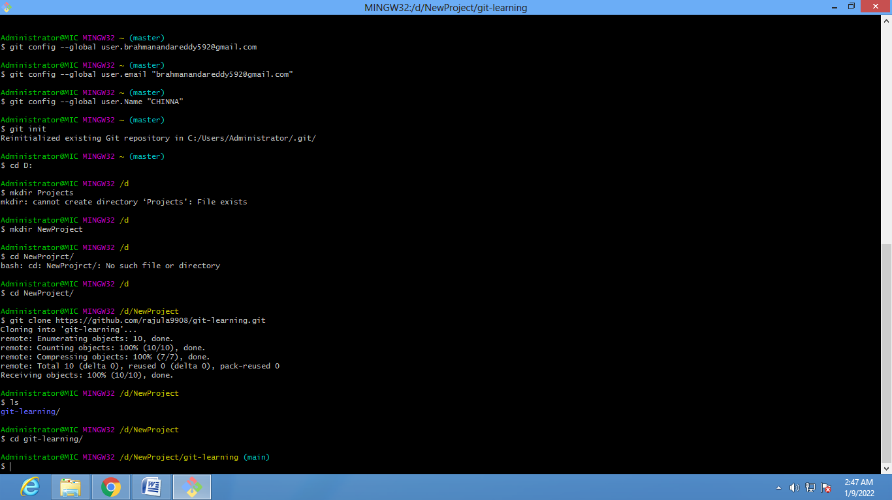

ls –al :-

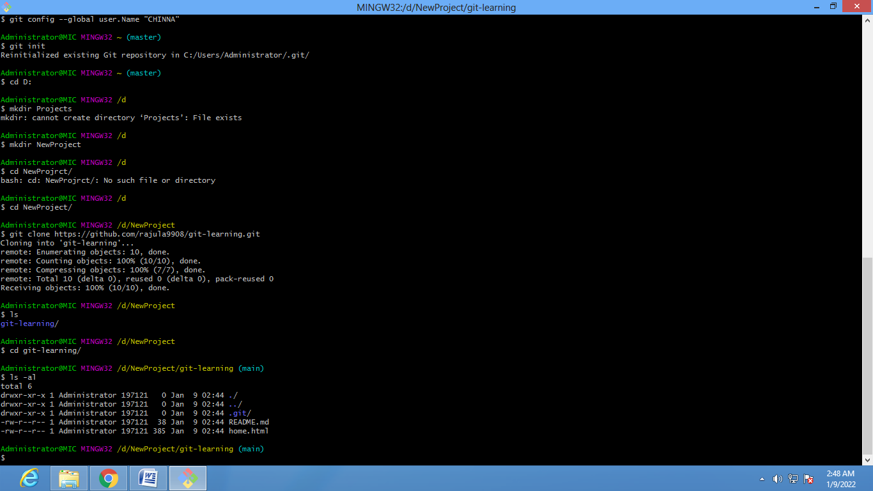

AFTER EDITING PUSH YOUR FILE INTO GIT HUB :-

* git add <file name>:-

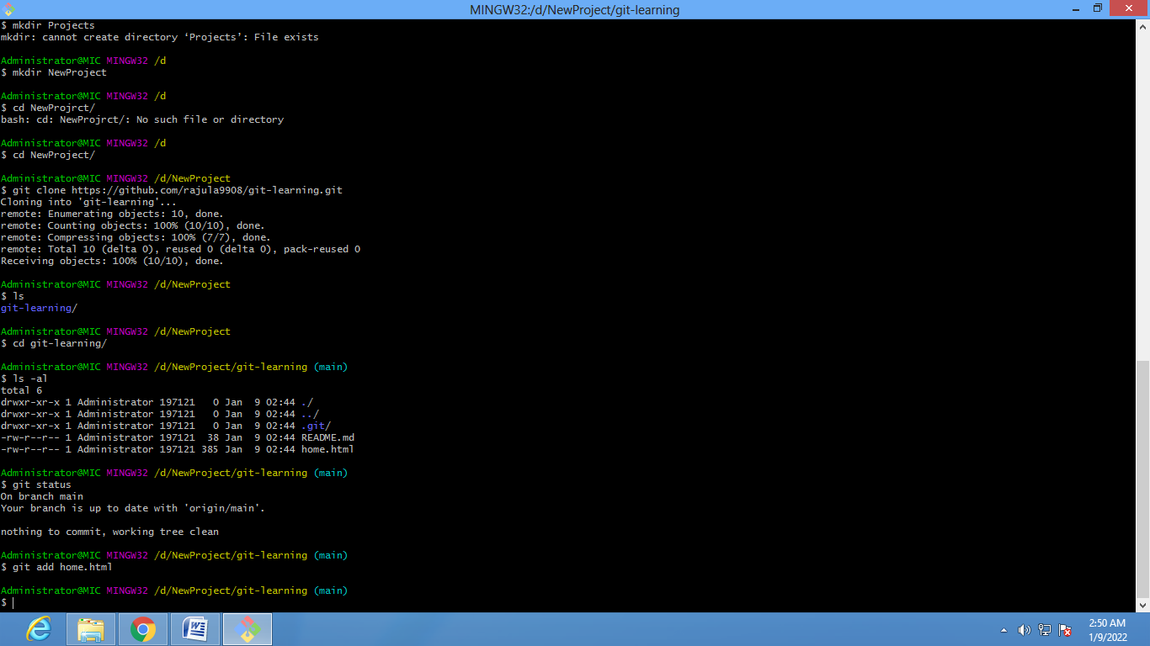

* git status:-

Staging Area to Local Repositray:-

* git commit –m “changes “
* git status

Local Repositray To Git Hub :-

* git push origin master